# MONITORING SOCIAL DISTANCING IN LOW LIGHT USING YOLOV5

**A Project Report submitted in partial fulfillment of the requirements for the award of the degree of**

**BACHELOR OF TECHNOLOGY IN**

**COMPUTER SCIENCE AND ENGINEERING**

**Submitted by**

|  |  |
| --- | --- |
| **TEJASWINI PASAM** | **121810305004** |
| **ANCHA YELLA MAHESH** | **121810305005** |
| **NEKKALAPUDI NITHIN SAI** | **121810305013** |
| **KOTA SANJEEV** | **121710305025** |

**Under the esteemed guidance of**

**MR.VENKATA SIVA NARAYANA G**

**ASSISTANT PROFESSOR, GIT**



**DEPARTMENT OF COMPUTER SCIENCE AND ENGINEERING GITAM**

**(Deemed to be university) VISAKHAPATNAM**

**March 2022**

**DEPARTMENT OF COMPUTER SCIENCE AND ENGINEERING GITAM INSTITUTE OF TECHNOLOGY**

**GITAM**

**(Deemed to be University)**



**DECLARATION**

We, hereby declare that the Project review entitled “**MONITORING SOCIAL DISTANCING IN LOW LIGHT USING YOLOV5**” is an original work done in the Department of Computer Science and Engineering, GITAM Institute of Technology, GITAM (Deemed to be University) submitted in partial fulfillment of the requirements for the award of the degree of B.Tech. in Computer Science and Engineering. The work has not been submitted to any other college or University for the award of any degree or diploma.

Date: March, 2022.

|  |  |  |
| --- | --- | --- |
| **Registration No:** | **Name:** | **Signature:** |
| **121810305004** | **TEJASWINI PASAM** |  |
| **121810305005** | **ANCHA YELLA MAHESH** |  |
| **121810305013** | **NEKKALAPUDI NITHIN SAI** |  |
| **121710305025** | **KOTA SANJEEV** |  |

**DEPARTMENT OF COMPUTER SCIENCE AND ENGINEERING GITAM INSTITUTE OF TECHNOLOGY**

**GITAM (Deemed to be University)**



**BONAFIDE CERTIFICATE**

This is to certify that the project report entitled **“MONITORING SOCIAL DISTANCING IN LOW LIGHT USING YOLOV5”** is a bonafide record of work carried out by **Ancha Yella Mahesh (121810305005),Tejaswini Pasam(121810305004),Nekkalapudi Nithin Sai(121810305013),Kota Sanjeev(121710305025)** submitted in partial fulfillment of requirement for the award of degree of Bachelors of Technology in Computer Science and Engineering.

**PROJECT GUIDE HEAD OF THE DEPARTMENT **

**Mr. VENKATA SIVANARAYANA G Dr. R.SIREESHA**

**(ASSISTANT PROFESSOR) (PROFESSOR)**

**CSE, GIT CSE, GIT**

**GITAM GITAM**

**ACKNOWLEDGEMENT**

We would like to thank our project guide **Mr.Venkata Sivanarayana G**, Assistant Professor, Department of CSE for her stimulating guidance and profuse assistance. We shall always cherish our association with her for her guidance, encouragement and valuable suggestions throughout the progress of this work. We consider it a great privilege to work under her guidance and constant support

We also express our thanks to the project's reviewers **DR**. **S Anuradha**, Assistant Professor, and **G Apparao**, Associate Professor, Department of CSE, GITAM(Deemed to be University) for their valuable suggestions and guidance for doing our project.

We consider it a privilege to express our deepest gratitude to **Dr.R Sireesha**, Head of the Department, Computer Science Engineering for his valuable suggestions and constant motivation that greatly helped us to successfully complete this project.

Finally, we deem it a great pleasure to thank one and all that helped us directly and indirectly throughout this project.

**Tejaswini, 121810305004**

**Yella Mahesh, 121810305005**

**Nithin Sai, 121810305013**

**Sanjeev, 121710305025**

### TABLE OF CONTENTS

**CONTENTS PAGE.NO**

|  |  |  |
| --- | --- | --- |
|  | **Declaration** | **1** |
|  | **Certificate** | **2** |
|  | **Acknowledgement** | **3** |
| **1.** | **Abstract** | **5** |
| **2.** | **Introduction** | **6** |
| **3.** | **Literature Survey** | **7** |
| **4.** | **Problem Identification & Objectives** | **10** |
|  | 4.1-Problem Identification |  |
|  | 4.2-Objectives |  |
| **5.** | **System Methodology** | **10** |
|  | 5.1-Data Selection | **10** |
|  | 5.2 Data Pre-Processing | **11** |
| **6.** | **Overview of Technologies** | **13** |
|  |  |  |
| **7.** | **Implementation**  **7.1 Coding** | **22** |
| **8.** | **Results** | **31** |
| **9.** | **Conclusion** | **33** |
| **10.** | **References** | **34** |
|  |  |  |

1. **ABSTRACT**

As we all are experiencing, this Covid-19 Pandemic changed all things. With its devastating spread over the world, the rampaging coronavirus illness 2019 (COVID-19) produced by the SARS-CoV-2 virus has created a global disaster. In the lack of effective therapy or vaccination, efforts are being made. To manage this pandemic, personal preventive steps, including handwashing, must be properly followed. Use of face masks, cleanliness of the environment, and, most significantly, social separation. Because of people's night meetings, low light surroundings can become an issue in the spread of disease. An issue can grow much more dangerous during the summer, when the global temperature is at its highest. Typically, in cities where people live in cramped housing and there is no suitable air cross-system in place. As a result, people devise strategies to get out of their homes with their family at night to obtain some fresh air. In such a situation they need to maintain social distance so as not to be affected by the virus.

In our project we focused on the detection of social distancing in low light conditions. In this situation maintaining social distance is very important to not spread the virus. In normal working hours we have some rules to follow social distancing but at night times and early mornings most of the people are not interested in following the social distancing. Most of the people want to enjoy nature and they chit chat with neighbors and friends and violate the social distance.

In this project we calculate the distance between the person to person and check whether the person is maintaining the required distance or not with the algorithm yolov5(you only look once) which is accurate in detection, all this work is done in low light situations like early morning or night times. which was helpful to impose fines or give counseling to the persons who are violating the social distancing.

Our Project includes: Data requirements Gathering, developing of machine learning model, Training of systems on our model, Testing, Obtaining Decision.

**2.INTRODUCTION**

COVID-19 is a coronavirus-related disease that was first detected in Wuhan, China, near the end of December 2020. On January 11, China confirmed the death of its first viral victim, a 61-year-old man. The World Health Organization (WHO) proclaimed it a pandemic on March 11th, citing its spread across 114 nations, 4000 deaths, and 118000 active cases.

From march 2020 to still today we are struggling with the covid 19 (coronavirus). In the first phase a lot of countries suffered huge losses in their economy and a lot of people died. In that situation the whole world followed some highly necessary rules like wearing masks, maintaining social distance and sanitizing hands and things, quarantine etc. Mainly China followed the rules very strictly like imposing 30 days quarantine on everyone and we saw some news like china-imposed shoot at sight orders on the people who violated the quarantine lockdown rules. It gave very good results for China, in a very small span of time China overcame the problem.

In this we mainly focused on monitoring social distancing in low light situations. For this we used the yolo algorithm which gives a good result in object detection. To achieve this we used the dark data set which has the images of different modules like people, vehicles, buildings, animals etc in low light.

In this project it gives a very precise solution for people detection to aid in the monitoring of social distancing at night People with congested homes, especially in the summer when the heat is at its worst, find methods to go out of their homes late at night with their family to obtain some fresh air. Object detection helps a lot in this deadly situation. Here we mainly focus on human detection i.e; we consider only people images in the dataset i.e; Exclusively dark dataset. For object detection we used the yolov5 algorithm which gives better results and good accuracy.

In this project we calculate the distance between the persons and check with our minimum distance, if the distance is greater than the minimum distance (1 meter) we show the bounding box in green color otherwise we show the bounding box in red color which means the people are not maintaining required distance.

**3.LITERATURE SURVEY**

We went through a lot of different research papers to understand all the previous work done on the project that we have undertaken. We have understood the following:

1. “Monitoring social distancing under various low light conditions with deep learning and a single motionless time of flight camera” in this paper they used the time of flight camera to capture pictures in low light, but we are not going to use the ToF camera, instead we use the dark data set which have low light pictures which is enough for the project
2. In the we referred used the algorithm yolov4 but in our project we used the yolov5 which is latest version of YOLO(you look only once) which gives better results than yolov4 and we get the high accuracy and better results with yolov5 than yolov4.
3. OVERVIEW OF YOLOV4:

The yolov4 mainly consists of

1.backbone

2.Neck

3.head

•**Backbone:** It employs CSPDarknet53 as a feature extractor with a graphics processing unit(gpu)

i)Bag of Freebies (BoF)

1.CutMix

We will cut the random patches from our training images and will paste those patches on other training images just to create new samples.

2.Mosaic data augmentation

We are combining four training images into one image with some certain ratio.

3.DropBlock regularization

dropblock is a similar method to dropout. Dropout removes pixels in a continuous manner ,we are working randomly and drops a block.

4.Class label smoothing

Basically we add some noise to class labels in class label smoothing.

ii)Bag of Specials(BoS)

1.Mish activation

Mish activation function provides much better accuracy overall lower loss,smoother.

It performs better over relu and leaky relu ,sigmoid, swish. It is combination of identity hyperbolic tangent and softplus

Y=X * tanh ( softplus ( X ) )

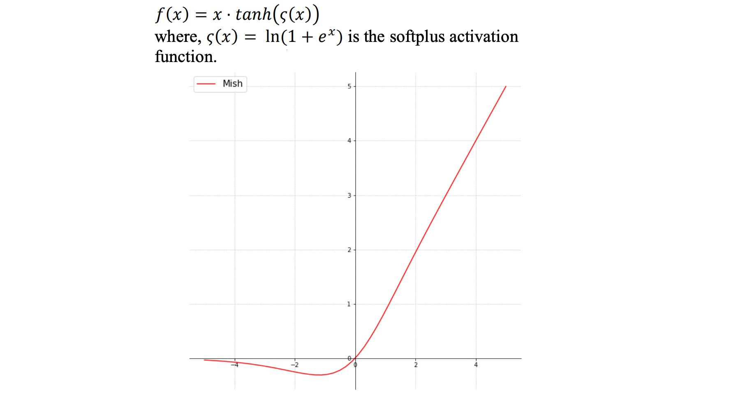

2.Cross-stage partial connections(csp)

Using csp we can improve the learning capability of the cnn network. The feature map of the base layer is splits into two parts through channel as X0= [ X1, X2 ]

The depth wise concatenation of the split feature maps x1 and x2 should give the transition. here x1 directly goto transition and x2 will goto the dense block first and then go to transition.

In this duplicacy is removed avoiding duplicate gradient information. while using backpropagation for weights updation we will not face the problem of vanishing gradients. Depth is decreasing computation will be less.

Dense block:group of convolutional layers which are connected with each other and each convolutional layer will have batch normalization and relu activation function ,output of every layer is input to the next layer.

3.Multi-input weighted residual connections

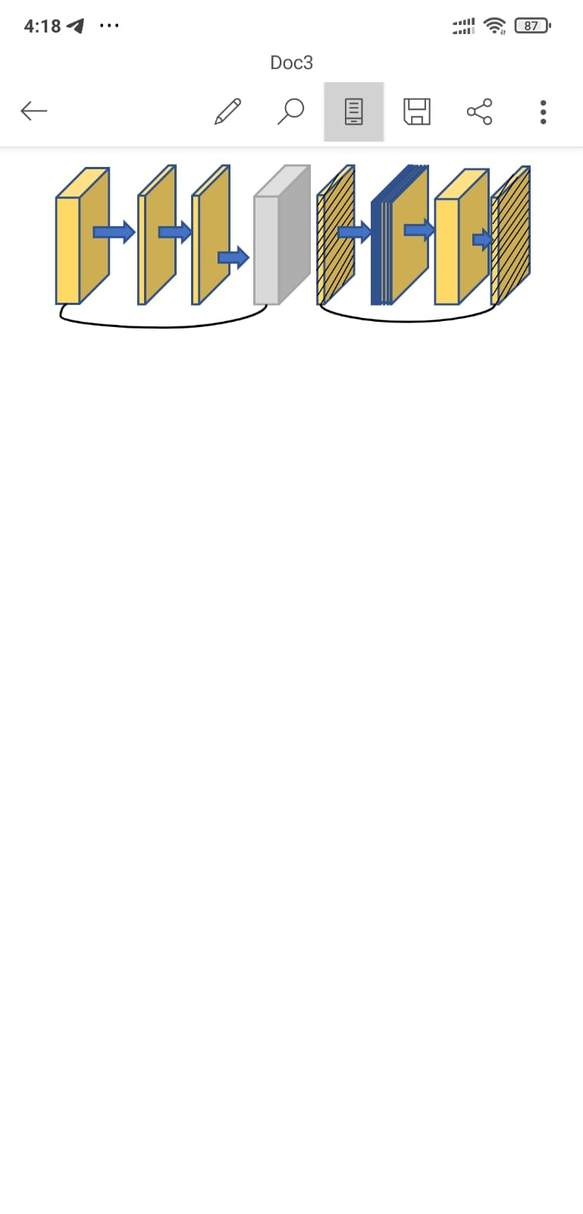

The right is inverted inverted residual and the traditional residual block is on the left side; these are the multi input weighted residual connections.

•**Neck:** It uses Path Aggregation Network (PAN) and Spatial Pyramid Pooling (SPP).

PAN:path aggregation network is connection between the layers ,each is connected with the previous layers.input of each layer is taken from the previous layer.

SPP:spatial pyramid pooling is a layer that removes the fixed size constraint of the network.i.e.a cnn does not require fixed size input image.The spp layer pools the features and generates fixed length outputs ,which are then fed into the fully connected layers

•**Head:** YOLOV3

.

**4.PROBLEM IDENTIFICATION OBJECT OF THE PROJECT**

**Problem Statement:**

During this pandemic lot people are neglecting to maintain social distance, especially at night times so in this project we come up with the idea of detecting distance between the people and highlighting the boundary box as green and red based on the distance between them. We are using the latest version of the yolov5 algorithm which gives better results and good accuracy.

**Objective:**

In this project we calculate the distance between the persons and check it with minimum distance(1 meter) . If the distance is greater than 1 meter we show the green boundary box which means the person is safe. If the distance is less than 1 meter we show the red boundary box which means the person is not maintaining the distance. All the people with green boundary boxes are in safe position and the persons with red boundary boxes are in danger. The project gives the good result of calculating social distance in low light conditions.

**5. SYSTEM METHODOLOGY**

To move into methodologies we need to understand what Machine Learning is. Machine Learning is an art of developing Models such that it provides the decisions as outcomes based on the past data in which it is being trained(training and testing datasets) without any Human Intervention. The steps involved in this model building methodology are represented as below.

**5.1 Data selection**

To develop our Machine Learning Model we need to train our model and most of the development process is totally dependent on datasets. So we need to get access for a huge collection of datasets hence we can move further in our model development. Many big firms provide free access to the Machine Learning Datasets as an encouragement to the developers and provide security for the data. Example: Google’s KAGGLE is an open source dataset management and model development platform for all machine Learning Enthusias.We get the dataset ExDark from the github <https://github.com/cs-chan/Exclusively-Dark-Image-Dataset/tree/master/Dataset> which has 7363 images.

The images are kept in individual class folders following the image class labels:

1.Bicycle - 652 images

2.Boat - 679 images

3.Bottle - 547 images

4.Bus - 527 images

5.Car - 638 images

6.Cat - 735 images

7.Chair - 648 images

8.Cup - 519 images

9.Dog - 801 images

10.Motorbike - 503 images

11.People - 609 images

12.Table - 505 images

Total : 7,363 images

**5.2 Data Preprocessing**

Pre-processing is defined as the transformations applied to our data before sending it to the algorithm. Data Preprocessing is a process where we can get clean data from raw data. Through preprocessing our data is meaningful.we gather the data from different sources and the data is considered as raw data which is not suggested for the analysis ,so we used the preprocessing technique to convert data into the meaningful.

FEATURES SELECTION

Feature Selection is the process where you automatically or manually select those features which contribute most to your prediction variable or output in which you are interested in.

Having irrelevant features in your data can decrease the accuracy of the models and make your model learn based on irrelevant features.

Feature selection and Data cleaning should be the first and most important step of your model designing, as they helps the model to:

**Reduces Overfitting:** Less redundant data means less opportunity to make decisions based on noise.

**Improves Accuracy:** Less misleading data means modeling accuracy improves.

**Reduces Training Time:** fewer data points reduce algorithm complexity and algorithms train faster.

**BUILDING CLASSIFICATION MODEL**

All machine learning models are categorized as either supervised or unsupervised.

Supervised learning is the machine learning task of learning a function that maps an input to an output based on example input-output pairs.

Unsupervised learning is a type of machine learning that looks for previously undetected patterns in a data set with no pre-existing labels and with a minimum of human supervision.

Since in our model we are planning to implement a Supervised Learning Model, we discuss further into the Supervised Learning Model.

If the model is a supervised model, it’s then sub-categorized as a **regression** or **classification** model.

**The Regression** Model consists of a set of **machine learning** methods that allow us to predict a continuous outcome variable (y) based on the value of one or multiple predictor variables (x). Briefly, the goal of a regressionmodel is to build a mathematical equation that defines y as a function of the x variables.

Example: Predicting prices of a house given the features of house like size, price etc is one of the common **examples** of **Regression**.

**Classification** refers to a predictive modeling problem where a class label is predicted for a given example of input data.

**5.3 Model**

**Overview of yolov5**

YOLOV5 is used for the detection which pre trained on coco dataset.it mainly consists of

i)Back bone

ii)Neck

iii)Head

i)Backbone:CSPDarkNet

In yolov5 CSPDarkNet is used as the backbone.Using csp we can improve the learning capability of the cnn network. The feature map of the base layer is splits into two parts through channel as

X0=[X1, X2]

The depth wise concatenation of the split feature maps x1 and x2 should give the transition. here x1 directly goto transition and x2 will goto the dense block first and then go to transition.

In this duplicacy is removed avoiding duplicate gradient information. while using backpropagation for weights updation we will not face the problem of vanishing gradients. Depth is decreasing computation will be less.

Dense block:group of convolutional layers which are connected with each other and each convolutional layer will have batch normalization and relu activation function ,output of every layer is input to the next layer.

SPATIAL PYRAMID POOLING:

SPP:spatial pyramid pooling is a layer that removes the fixed size constraint of the network.i.e.a cnn does not require fixed size input image.The spp layer pools the features and generates fixed length outputs ,which are then fed into the fully connected layers.

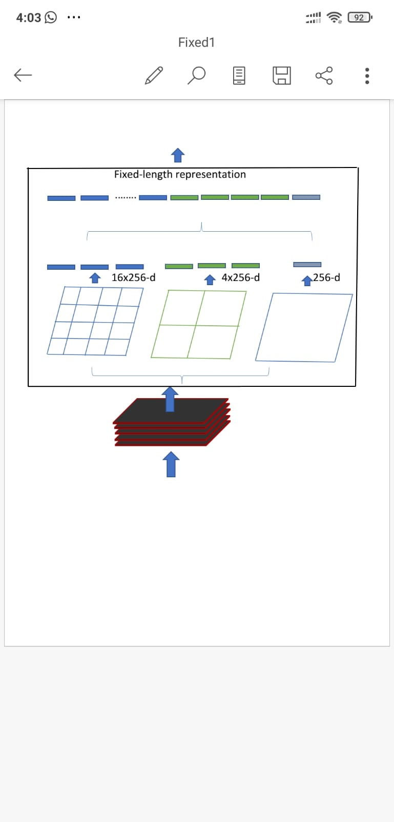

NECK:PANet

It is certainly worth noting here that YOLOv5 borrows research inquiry from YOLOv4 to decide on the best neck for their architecture. YOLOv4 investigated various possibilities for the best YOLO neck including:PAN

PAN:path aggregation network is connection between the layers ,each is connected with the previous layers.input of each layer is taken from the previous layer.

HEAD:YOLO

Yolo used for object detection and to achieve this yolo uses neural networks this algorithm is popular because of its speed and accuracy .we have many uses by yolo we can use it cctv cameras to detect the people.yolo is very efficient and give better accurate values compared to other detecting algorithms.it has

1.Residual blocks:image is splitted into several parts i.e. grids ,each part has N x N dimension.

2.bounding box regression 3.intersection over union:

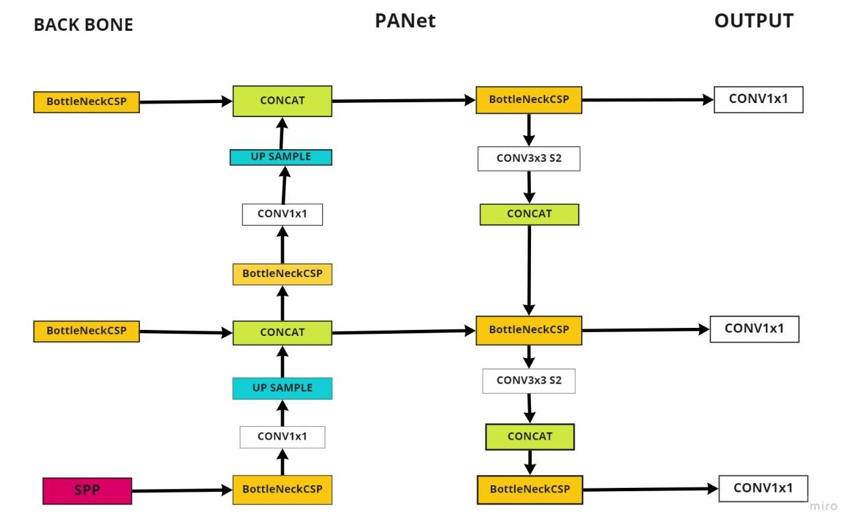

**TRAINING DATASET AND TESTING DATASET**

**TRAINING DATASET**: The observations in the training set form the experience that the algorithm uses to learn. In supervised learning problems, each observation consists of an observed output variable and one or more observed input variables.

**TESTING DATASET**: The test set is a set of observations used to evaluate the performance of the model using some performance metric. It is important that no observations from the training set are included in the test set. If the test set does contain examples from the training set, it will be difficult to assess whether the algorithm has learned to generalize from the training set or has simply memorized it.

A program that generalizes well will be able to effectively perform a task with new data. In contrast, a program that memorizes the training data by learning an overly complex model could predict the values of the response variable for the training set accurately, but will fail to predict the value of the response variable for new examples. Memorizing the training set is called **over-fitting**. A program that memorizes its observations may not perform its task well, as it could memorize relations and structures that are noise or coincidence. Balancing memorization and generalization, or overfitting and under-fitting, is a problem common to many machine learning algorithms. **Regularization** may be applied to many models to reduce overfitting.

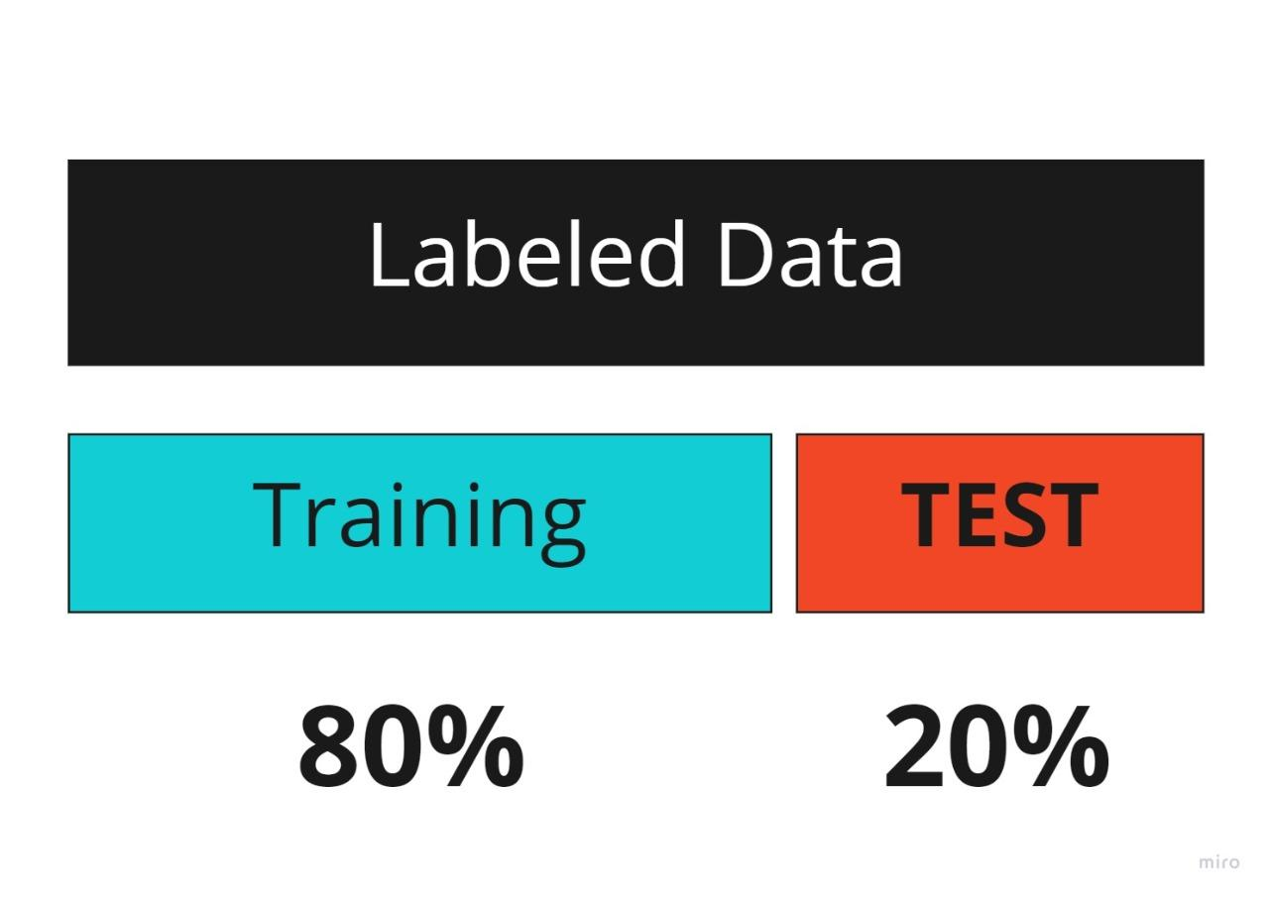

**EVALUATING PREDICTIONS**

Evaluating your machine learning algorithm is an essential part of any project. Most of the time we use classification accuracy to measure the performance of our model, however it is not enough to truly judge our model.

So, one of the evaluation matrices is the Confusion Matrix.

Confusion Matrix as the name suggests gives us a matrix as output and describes the complete performance of the model.

There are 4 important terms:

**True Positives**: The cases in which we predicted YES and the actual output was also YES.

**True Negatives**: The cases in which we predicted NO and the actual output was also NO.

**False Positives**: The cases in which we predicted YES and the actual output was also NO.

**False Negatives**:The cases in which we predicted NO and the actual output was also YES.

**FIG:CONFUSION MATRIX**

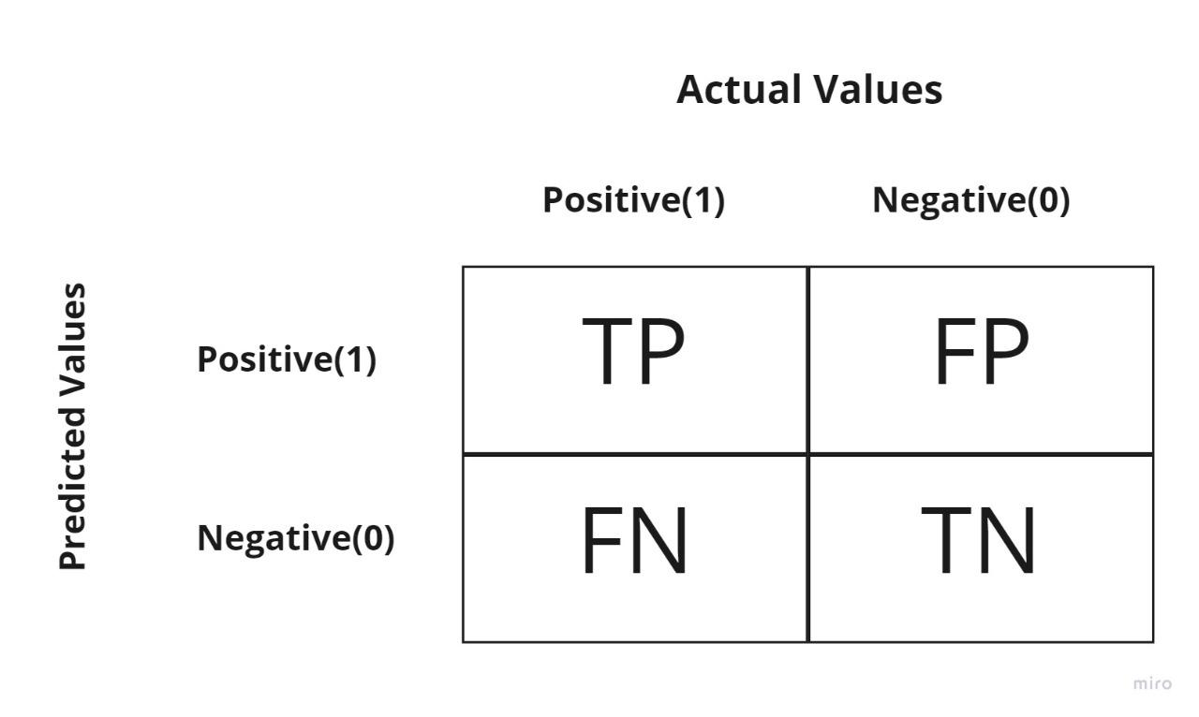

**F1-score:** This is the harmonic mean of Precision (focus on predicted positives) and Recall (focus on actual positives) and gives a better measure of the incorrectly classified cases than the Accuracy Metric.

F1_Score= 2/(1/precise + 1/recall)

**VISUALIZATION**

**VISUALIZATION OF EXISTING SYSTEM**

Fig:Existing System

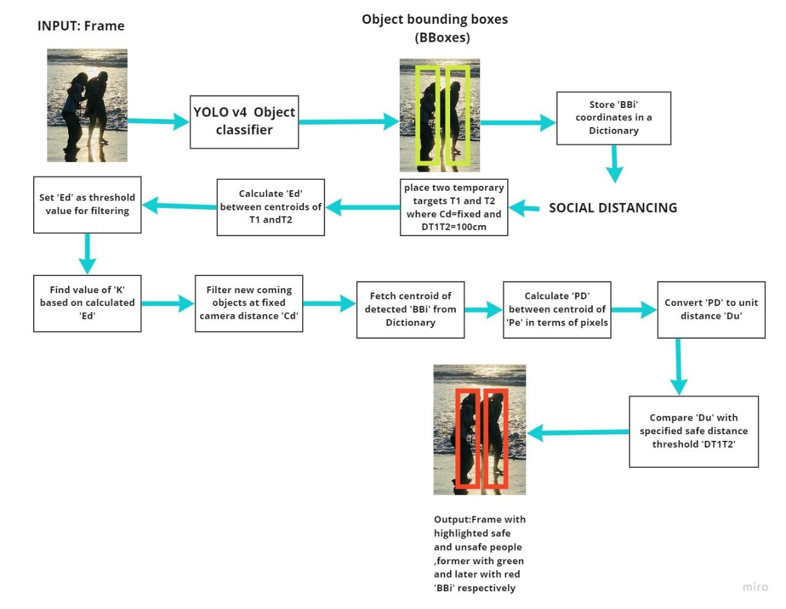

**VISUALIZATION OF PROPOSED SYSTEM**

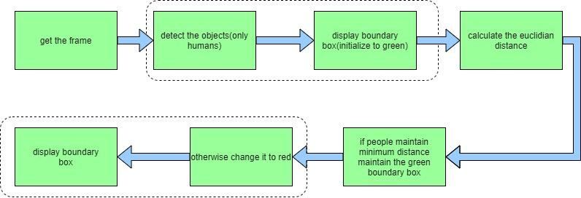

In our proposed model,First we take the input, and divide the data into two parts: training part and testing part. here we pass the data to the yolov5 algorithm which is already trained on coco dataset then it detects the boundary boxes to the people.from this we calculate centroid of each boundary box and using these centroids we calculate the distance between the persons.check distance between the persons less than p pixels(minimum distance) add them to violate set otherwise add them non violate set.if the person is in violate set the color of the boundary box of the person is red otherwise the boundary box color is green.

**ER DIAGRAM:**

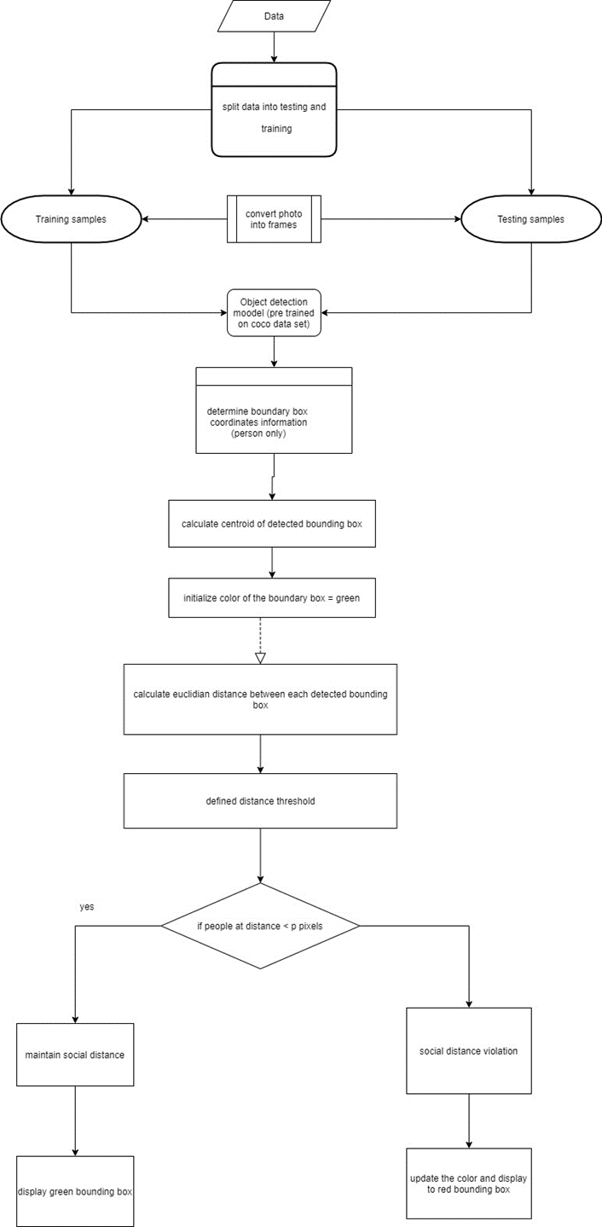

**TECHNOLOGY STACKS WE USE ARE:**

**GOOGLE COLABORATORY** as Development environment.

It is an open-source web application that allows anybody to write and execute arbitrary python code through the browser, and is especially well suited to machine learning, data analysis.

With Colab you can import an image dataset, train an image classifier on it, and evaluate the model, all in just a few lines of code.

**PYTHON** Programming language

Python offers concise and readable code. While complex algorithms and versatile workflows stand behind machine learning and AI, Python’s simplicity allows developers to write reliable systems. Developers get to put all their effort into solving an ML problem instead of focusing on the technical nuances of the language.

Additionally, Python is appealing to many developers as it’s easy to learn. Python code is understandable by humans, which makes it easier to build models for machine learning.

Python Modules like PANDAS, NUMPY, MatPlotLib , Scikit Learn

**Pandas** can easily fetch data from different sources like SQL databases, CSV, Excel, JSON files and manipulate the data to perform operations on it.

**MatPlotLib** is a standard Python library used by every data scientist for creating 2D plots and graphs. It’s pretty low-level, meaning it requires more commands to generate nice-looking graphs and figures than with some advanced libraries.

**IMPLEMENTATION**

**1.Mount google drive**

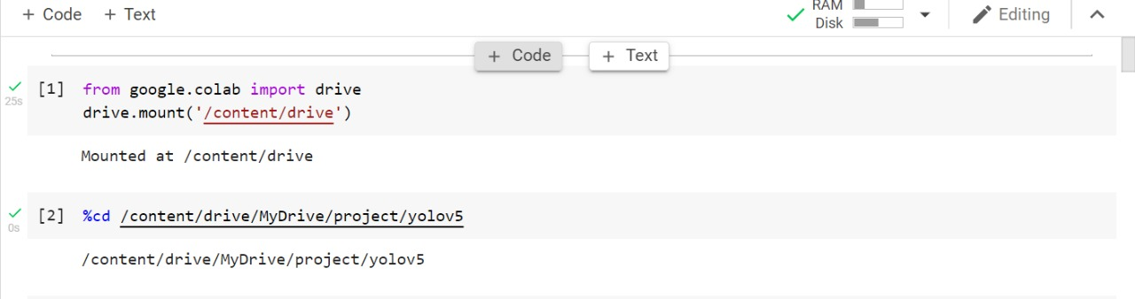

To begin first we need to mount the google colab with google drive. %cd-To change the directory location to Yolov5

**2.Installing requirements i.e; libraries**

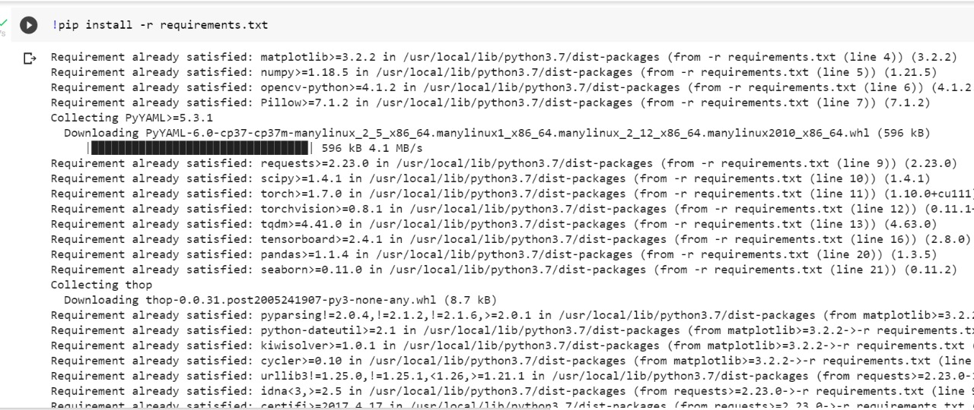

To begin with implementation we need to install some libraries:

**matplotlib-**For visualizing the data points such as creating 2D plots and graphs

**numpy-**Solving Matrices, Representing Array, etc

**3.Training the dataset**

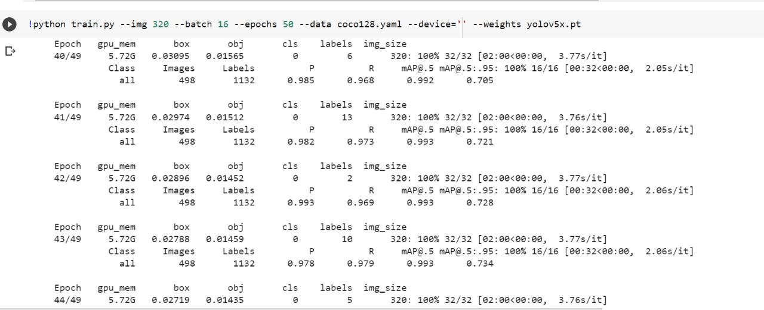

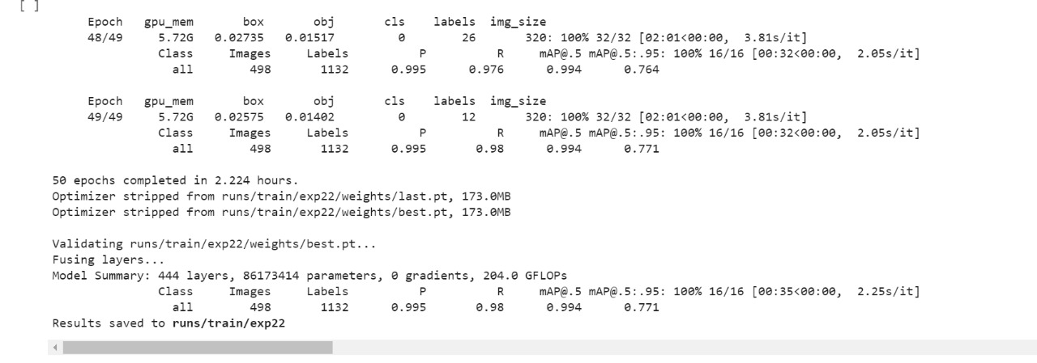

Here,

Network size-320,416 (The number of nodes in the model)

Batch size-16 (Number of training examples utilized in one iteration.

Number of samples processed before the model is updated.)

Epochs-50 (Number of complete passes through the training dataset.

Epoch means training the neural network with all the training data for one cycle)

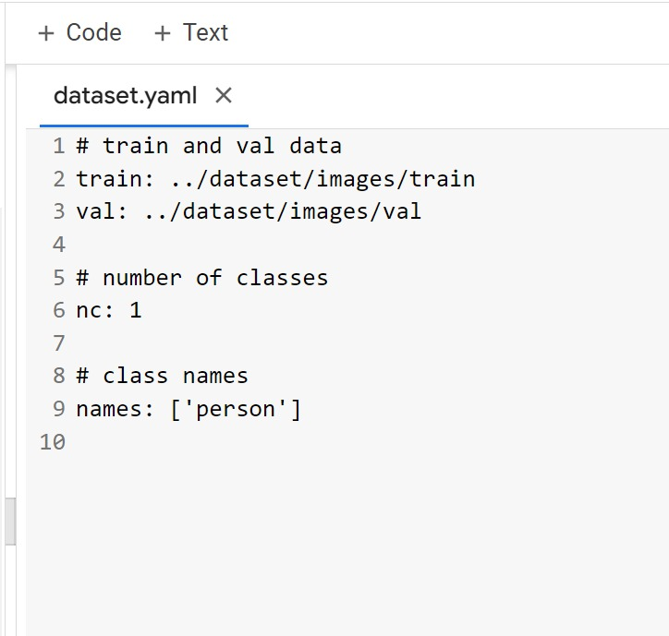

yolov5 needs a yaml file,given the one class i.e; person .The weight used :yolo V5x

**4.Validation of dataset**

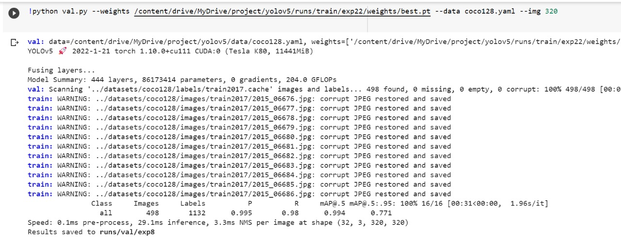

**5.Detection the dataset**

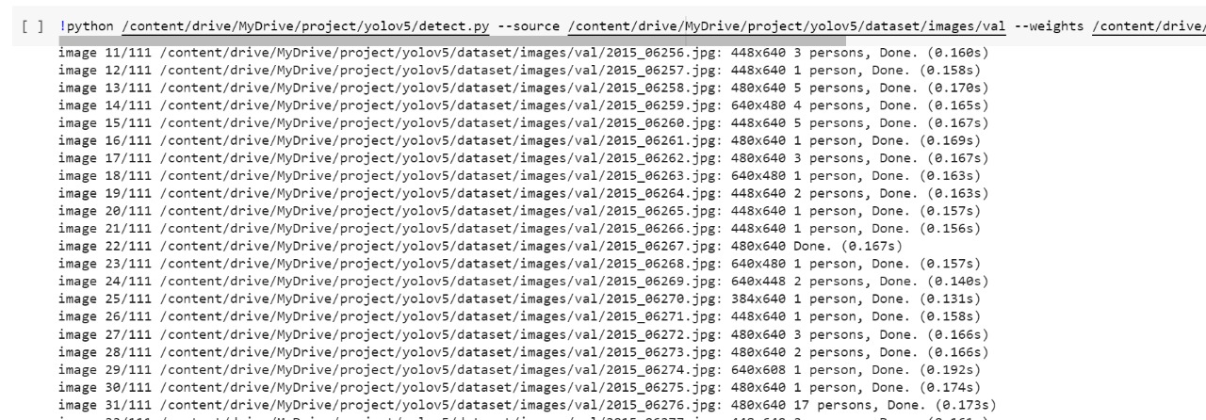

**6.Output for detection**

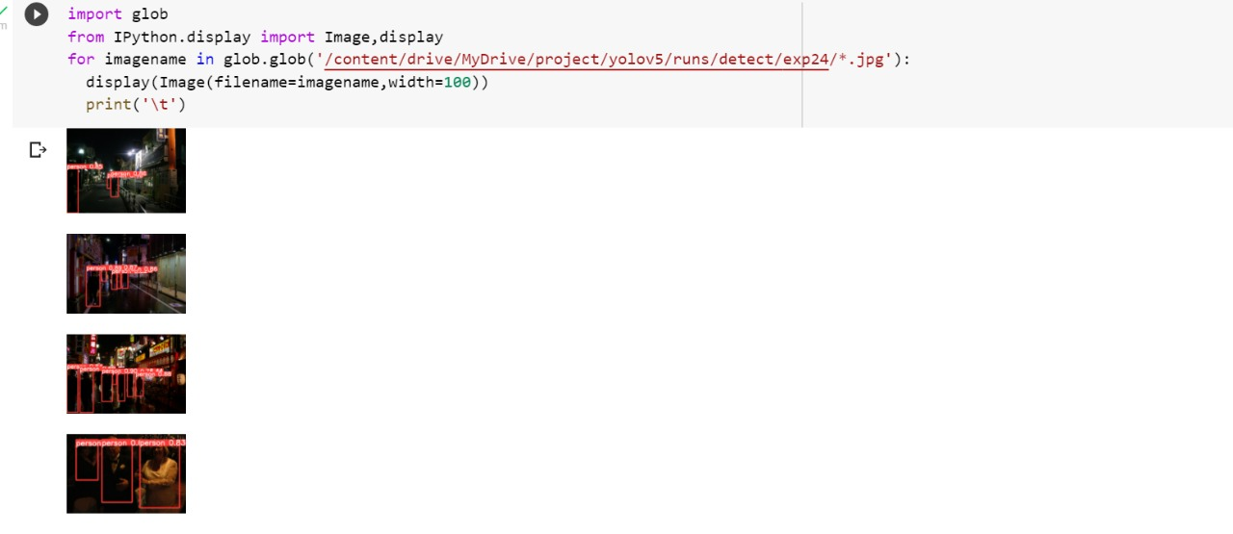

import glob- to retrieve the files/pathnames.

display(Image(filename=imagename,width=100)-To display the images.

**7.Distance Calculation**

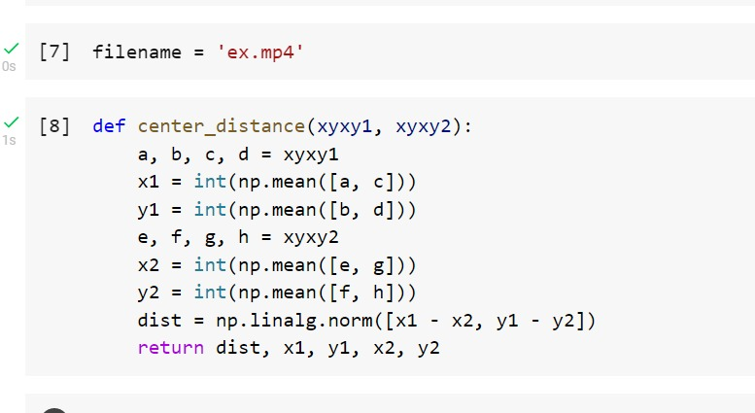

Input-as video i.e; ex.mp4

To define center_distance() function for calculating the distance between the coordinates. np.linalg.norm-used to calculate the norm of a vector or matrix,so just to calculate the Frobenius form (x1-x2) and also for distance calculation.

**8.Detection people on frame**

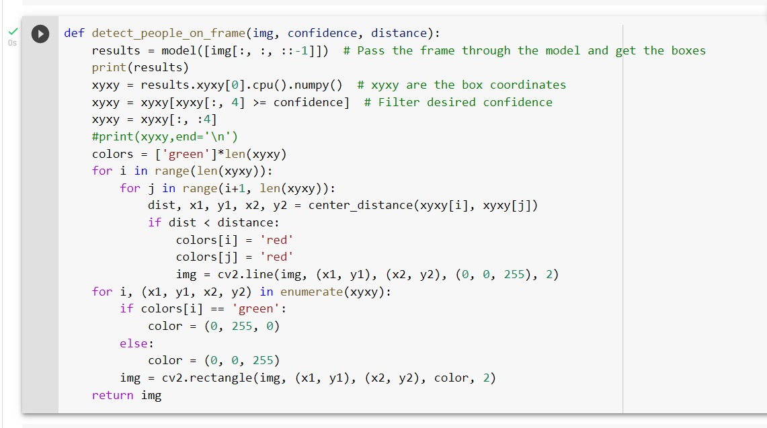

In detect_people_on_frame() function passed arguments (img, confidence, distance). Next, Pass the frame through the model and get the boxes.Here, get the xyxy as box coordinates.Next,call the center_distance() function and got the distance between the two boundary boxes then check the condition between the actual distance and calculated dist and if (dist < distance) then the boundary box results as red color otherwise the boundary box remains as green color.

**9.Detection People on video**

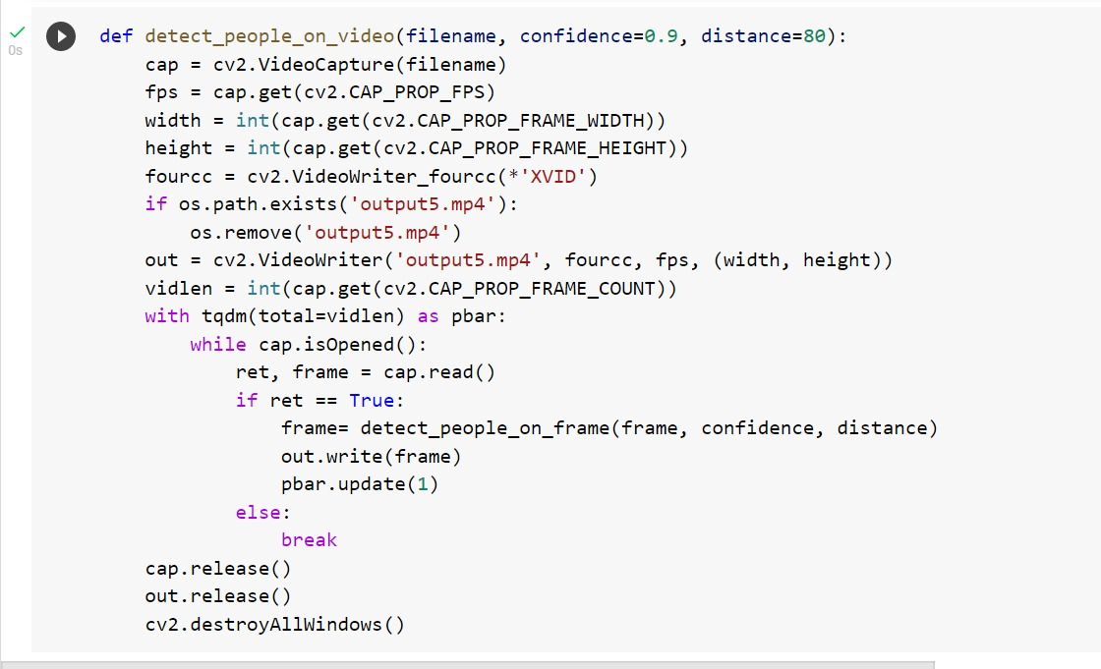

In the detect_people_on_video() function pass the argument as(filename,confidence,distance) . From here get the frames from the video and pass the frame to the detect_people_on_frame() function and save the result into output5.mp4. Then call the function detect_people_on_video and pass the input ex.mp4 as filename and confidence=0.5.

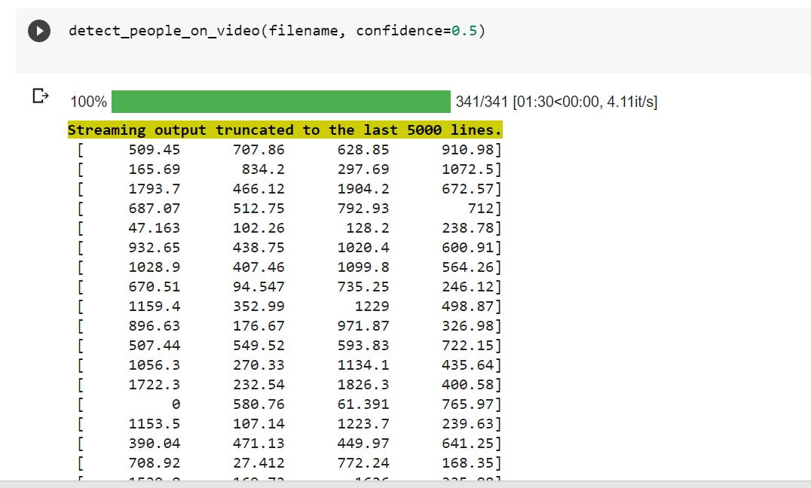

**10.Displayed the output**

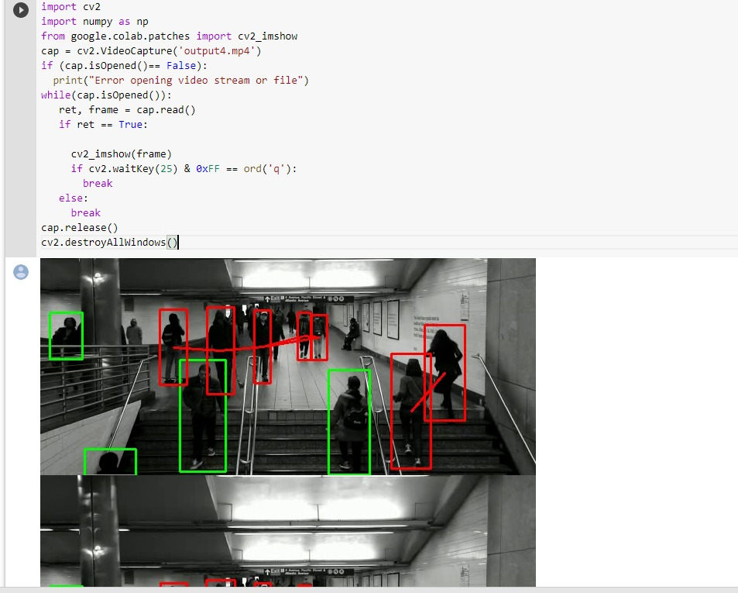

**EXPERIMENT RESULTS**

Existing :

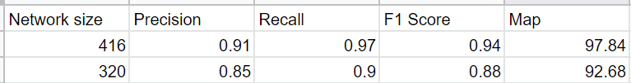

Proposed:

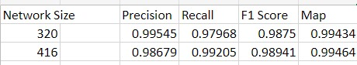

In existing they used the yolov4 algorithm but to improve accuracy we used the yolov5 algorithm. Above are the results for existing and proposed.

**CONCLUSION:**

This article proposes an efficient solution for real-time social distance monitoring in low light environments. For real-time person detection, the YOLO v4 algorithm is trained on the ExDARK dataset. For monitoring social distance, a motionless ToF camera is used to observe people at fixed camera distance and show resultant distance in real-world units. Safety distance violations are highlighted. The proposed YOLO v4 based real-time social distance monitoring solution is evaluated by COCO detection metrics. Experimental analysis shows that the YOLO v4 algorithm achieved the best results in different low light environments with 97.84% mAP score and the observed MAE value during the test of our social distance monitoring approach is 1.01 cm. The FPS score can be more enhanced by fine-tuning the same approach on GPUs like Volta, Tesla V100, or Titan Volta. The proposed technique can be easily applied in real-world scenarios because of high precision and the low error rate, e.g., in banks to help the cashier to monitor people standing in front of him, in shops to help shopkeepers to observe customers, in train stations to help ticket giver to keep track of people violating safe distance, etc. In the future, we will extend our system to monitor social distance at varying camera distances by managing objects varying camera angles.

**References:**

**Article:**

**-Adina Rahim,Ayesha Maqbool ,Tauseef Rana**[**Monitoring social distancing under various low light conditions with deep learning and a single motionless time of flight camera (plos.org)**](https://journals.plos.org/plosone/article?id=10.1371/journal.pone.0247440)

**Tool :**

[**Make Sense**](https://www.makesense.ai/)

**Article:**

[**A deep learning-based social distance monitoring framework for COVID-19 - PMC (nih.gov)**](https://www.ncbi.nlm.nih.gov/pmc/articles/PMC7603992/)

**News:**

[**Preventing the spread of the coronavirus - Harvard Health**](https://www.health.harvard.edu/diseases-and-conditions/preventing-the-spread-of-the-coronavirus)

**Article:**

[**https://www.sciencedirect.com/science/article/pii/S1077314218304296?via%3Dihub**](https://www.sciencedirect.com/science/article/pii/S1077314218304296?via%3Dihub)

**Article:** [**https://economictimes.indiatimes.com/tech/software/how-countries-are-using-technology-to-fight-coronavirus/articleshow/74867177.cms**](https://economictimes.indiatimes.com/tech/software/how-countries-are-using-technology-to-fight-coronavirus/articleshow/74867177.cms)

**Article:**

[**https://wellcomeopenresearch.org/articles/5-81/v2**](https://wellcomeopenresearch.org/articles/5-81/v2)